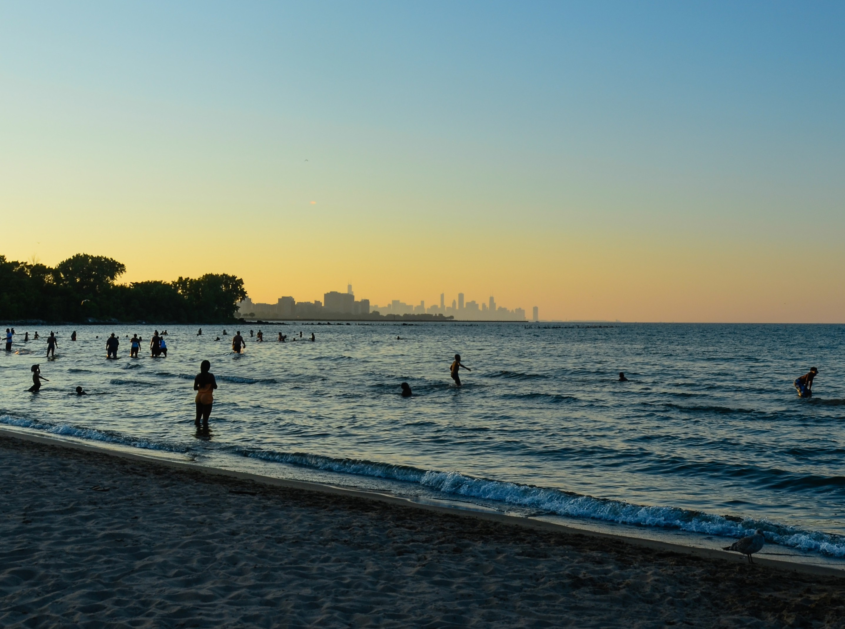

The Chicago Lakefront:
Protected, Yet Precarious



An Openlands Report 2025

The intrinsic value of open space—the very amenity that is synonymous with the lakefront and considered its signature attribute— has been largely taken for granted, rather than central to the public discourse.

The future defense of the city’s cherished shoreline relies on the public’s understanding of how the lakefront protection system works and how to strengthen it.

Preamble
For thousands of years before European contact, Indigenous nations—including the Potawatomi, Ojibwe, and Odawa—protected, lived, and traded along the shores of Lake Michigan, which was central to their way of life. The name ‘Michigan’ derives from the Algonquian word Mishigamaw, meaning ‘big lake’ or ‘great water.’ Today, Chicago has the largest Native American population in the Midwest.¹ To learn more about indigenous peoples’ history with the lakefront, visit whoselakefront.com.

Introduction
Since the incorporation of Chicago in 1837, lakefront champions have used law and legal precedent to keep the city’s iconic lakefront open, accessible, and for the public. While protections have been effective, they remain susceptible to political influence and procedural gaps. Occasionally, they have been loosely interpreted, adulterated by concessions, or outright circumvented and ignored.

As the city contemplates multi-billion-dollar developments that could reshape the lakefront, those risks loom large once again. Much of the public debate about these proposals has concentrated
on the economic benefits they might induce. Yet, the intrinsic value of open space—the very amenity that is synonymous with the lakefront and considered its signature attribute—has been largely taken for granted, rather than central to of the public discourse.

This problem has perpetuated an unfortunate pattern in Chicago history: While the city has always professed allegiance to its founding creed for a lakefront “forever open, clear, and free,” its actions have often come into tension with that principle. This is partly due to a system of laws that have proven
relatively stout in stifling overzealous lakefront development proposals once they have surfaced, but less adequate in preventing them from threatening harm in the first place. As a result, serial public debate about individual development proposals leads to recurring legal disputes over dwindling open space and unhealthy discourse about the lakefront’s future overall.

As this analysis illustrates, the city can change this cycle for the better by instituting necessary reforms.

That endeavor starts with a comprehensive review of existing lakefront protection laws, specifically those that govern a majority of the shoreline: the public trust doctrine and the Lake Michigan and Chicago Lakefront Protection Ordinance (LPO).² For as durable as these legal bulwarks have proven to be over Chicago’s history, they are subject to erosion. The future defense of the city’s cherished shoreline relies on the public’s understanding of how the lakefront protection system works and how to strengthen it.
This report informs that understanding by describing the legal infrastructure that protects the lakefront and proposing improvements that would bolster its might when threats emerge.

By gaining a deeper understanding of the lakefront’s governance and identifying areas for improvement, we can ensure its shores remain Chicago’s most enduring civic asset.

Cover: Chicagoans enjoy the lakefront at sunset near the South Shore Cultural Center.




While many other cities have industrialized or privatized their waterfront, Chicago’s roughly
3,400 acres of lakefront parks stand out among global cities.

Above, right: Just across the state line, Gary Works in Indiana illustrates a stark contrast—Lake Michigan shoreline dominated by heavy industry rather than public space.

Left: Healthy coastal ecosystems provide birds and other wildlife with essential resources for food, shelter, breeding grounds, and migration.

Lakefront Advocates and Visionary Planning:
Background and Historical Origins of Lakefront Laws
Imagine a Chicago without the benefits of a public lakefront— ecological, cultural, economic, civic, and health. It would be scarcely recognizable and certainly lack the luster the city possesses today.
Chicago’s scenic landscape is a globally unique urban asset that draws talent, capital, and commerce to the city. With the longest contiguous access to a waterfront of any city in the United States, it is no wonder Chicago is a perennial favorite of tourists and big-city top 10 lists.

The 50-plus mile Chicago lakefront trail and footpath system³ is one of the busiest in the country, with more than 30,000 daily users
during the summer months.⁴ On land and in the water, vital habitats shelter and feed critical wildlife. The lakefront guides millions
of migratory birds each spring and fall as part of the Mississippi Flyway.⁵ While many other cities have industrialized or privatized their waterfront, Chicago’s roughly 3,400 acres of lakefront parks stand out among global cities.

The lakefront Chicagoans enjoy today is the outcome of generations of civic leaders, city planners, and open-space advocates who prioritized public benefit over private interest and demanded legal protections and visionary planning. In the 19th century, as railroads and other industries sought to acquire lakefront land downtown, citizens like Aaron Montgomery Ward fought in court and the public square to protect it, utilizing the public dedication doctrine and the public trust doctrine. As the sidebar on page 3 explains, the public dedication doctrine represents Chicago’s earliest expression of its quest to preserve the lakefront as a public amenity.

The Public Dedication Doctrine
The public dedication doctrine and the public trust doctrine may be confused when discussing lakefront protections, but it is important to understand their differences. The relationship between the two can be thought of as concentric circles: the public dedication doctrine applies to a specific area of the lakefront— specifically Grant Park—while the public trust doctrine has a broader application across the lakefront, especially in areas where the lakebed has been filled and is now in public ownership. Additionally, the public dedication doctrine recognizes the rights of landowners adjacent to the dedicated area, whereas the public trust doctrine allows any citizen to file a lawsuit if public use is being violated
or exploited. While the public dedication doctrine has a narrower focus, it played a crucial role as one of the earliest laws governing land use along the lake, paving the way for stronger protections in the future.
In 1829, the newly incorporated State of Illinois created the Board of Canal Commission to build the Illinois-Michigan Canal, connecting the Great Lakes to the Gulf of Mexico. To pay for the project, the state granted land along the canal path to this commission, which would survey and sell the land to the public.

In 1833, the commission surveyed the City of Chicago. Recognizing that people value clean air, sunshine, and scenic views, the commission raised the price of lots along Michigan Avenue with unobstructed lake views. However, those open-space values needed to be preserved to attract wealthy buyers. Therefore, they protected the open space through dedication as “Public Ground—A Common to remain forever Open, Clear and free of any buildings,
or other Obstructions Whatever.” The properties on the western side of Michigan Avenue quickly became homes for Chicago’s elite.⁶
The public dedication doctrine was used by residents, led by business leader and retailer Montgomery Ward, to block lakefront development in several cases between 1890 and 1910. It can still be invoked today to take legal action against intrusive development within Grant Park. However, recent court rulings and the construction of new buildings in Millennium and Maggie Daley Parks may
limit the doctrine’s effectiveness. In this report, the public dedication doctrine is referenced as a precedent for the legal intent behind lakefront protection.

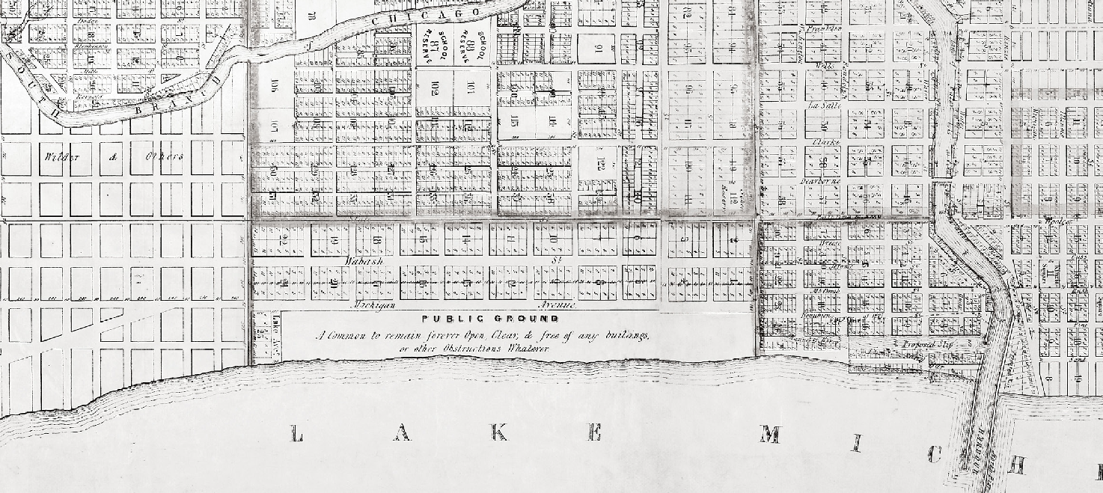
An 1836 map by the Illinois and Michigan Canal Commissioners designates what is now Grant Park as “Public Ground—A Common to remain forever Open, Clear and free of any buildings, or other Obstructions Whatever.” This early declaration reflects a promise made to the people of Chicago—one that residents and advocates have been working to uphold for nearly two centuries.

An 1836 map by the Illinois and Michigan Canal Commissioners shows an area now known as Grant Park to be, “Public Ground— A Common to remain forever Open, Clear and free of any buildings, or other Obstructions Whatever.”

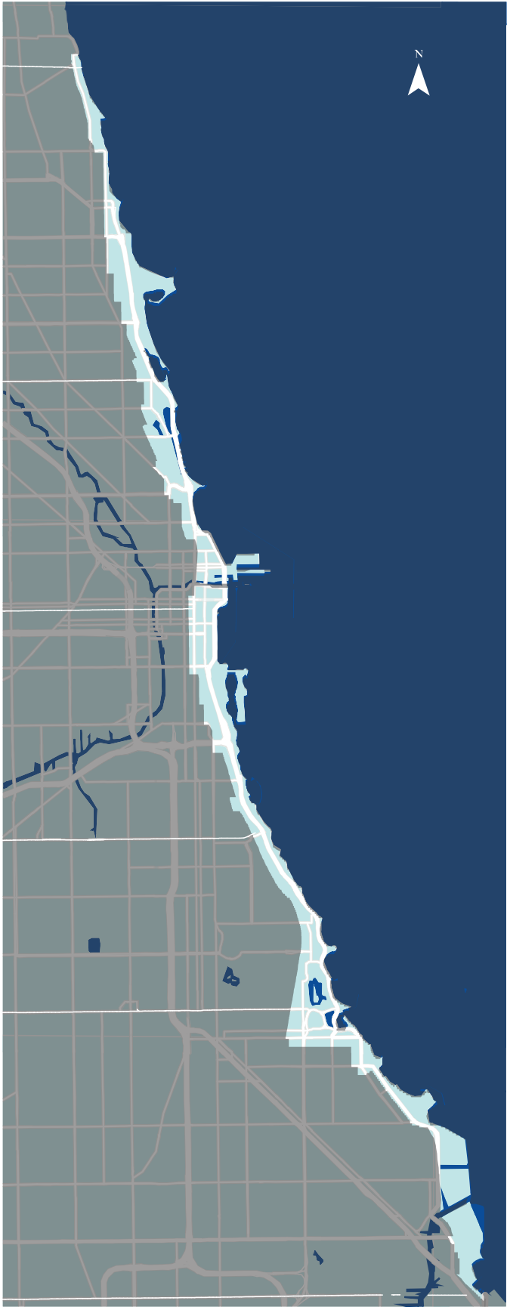
As debates over lakefront land use continued to surface at the beginning of the 20th century, cul- tural factors placed a new premium on shepherding the city’s growth without sacrificing the value of natural resources and the importance of public health. That budding emphasis on conservation, led by the visionary planning of Daniel Burnham and Edward Bennett, among others, spurred the creation of the Chicago Plan Commission, the Chicago Park District, zoning regulations, and environmental laws (see timeline page 5).
HOWARD
The Chicago Lakefront
BELMONT
MADISON
PERSHING
63RD
103RD

By the middle of the 20th century, large-scale developments such as the opening of McCormick Place in 1960 encroached on the lakefront, and
a new wave of environmentalism caused many observers to fret about the longevity of Chicago’s vaunted commitment to preserving its shoreline parks. In response, residents again pushed back against lakefront intrusion and advocated for creating the Lake Michigan and Chicago Lakefront Protection Ordinance in 1973.

Today, more than 50 years after the passage of that consequential lakefront ordinance, several intrusive development proposals (see sidebar, page 10) have passed through the City’s review process, only to be slowed down or stopped through litigation. From the Chicago Children’s Museum and the Lucas Museum, which both succumbed to opposition, to the successful bid to build the Obama Presidential Center, the battles
over these proposed projects illustrate the complex yet crucial legal protections that safeguard the lakefront. They also illuminate how the current culture of lakefront governance leads to defensive rather than proactive public debates on how to protect public lands.

For the purposes of this report, the land that constitutes the lakefront is the area covered by the public and private use zones of the Chicago Lakefront Protection District along with areas of Lake Michigan infill, which is covered by the public trust doctrine, represented in this map. In total, the lakefront encompasses an area of approximately 6,400 acres and a distance of roughly
25 miles north to south of the city limits.

Key Milestones That Shaped Chicago’s Lakefront

Pre-1818 Native people inhabit the shoreline for thousands of years, protecting it and using it for sustenance, transportation, and trade.

1818 Illinois gains statehood.

1836 The Board of Canal Commission surveys Chicago and dedicates land along the lakefront as “A Common to remain forever Open, Clear, and free of any buildings or other Obstructions Whatever.”

1837 The City of Chicago is incorporated.

1857 The facility that would eventually become U.S. Steel’s South Works site begins operation under the name of the North Chicago Rolling Mill.

1892 The U.S. Supreme Court hears Illinois Central R. Co. v. Illinois and holds that the lands under the waters of Lake Michigan are owned by the state in trust for public benefit, thus establishing the public trust doctrine as the law of the land.

1900 The flow of the Chicago River is reversed.
1909 The Plan of Chicago is published. The city creates the Chicago Plan Commission to implement the Plan.
1973 The City of Chicago passes the Lake Michigan and Chicago Lakefront Protection Ordinance, applicable within three lakefront zones and with 13 stated purposes.

1986 Governor James Thompson authorizes the sale of 16 acres of Lake Michigan to Loyola University to infill and expand the campus. It is approved by the Chicago Plan Commission, zoning committee, and City Council but is never built due
to legal challenges under the public trust doctrine. DuSable Lake Shore Drive’s “S-curve” is reconstructed.

1992 U.S. Steel closes.

1995 Navy Pier is reintroduced to the public as a mixed-use venue incorporating retail, dining, entertainment, and cultural spaces.

1998 The Metropolitan Pier and Exposition Authority is created to manage and operate Navy Pier and McCormick Place.

2000 South DuSable Lake Shore Drive begins reconstruction, adding new parkways, beaches, and access points to the Lakefront for South Side residents.
2002 Soldier Field begins renovations for the Chicago Bears. 2003 Meigs Field abruptly ceases operation when its runway is
destroyed by City crews.
1916 | Municipal Pier (now known as Navy Pier), envisioned as part of the Burnham Plan, opens to the public.
1921 | The Field Museum opens.

2004 Millennium Park opens.

2005 The Chicago Park District opens the Lakefront Pavillion on

1922
The Little Calumet River is reversed.
Northerly Island, now named the Huntington Bank Pavillion on Northerly Island. In 2013, the Park District gains approval

1923 Chicago adopts a city-wide zoning ordinance. 1924 Soldier Field construction is completed.

Hollywood Avenue.

1959 The proposal to turn DuSable Lake Shore Drive into an interstate is thwarted.

as a significantly larger convention hall.

1972 Mayor Richard J. Daley’s administration publishes The Lakefront Plan of Chicago, which includes 14 basic policies for the lakefront.
to expand the entertainment complex.

2008 The Chicago Children’s Museum gains approval from the Chicago Plan Commission, zoning committee, and City Council to build in Grant Park. It never does due to legal challenges under the public dedication doctrine.

2013 The extension of DuSable Lake Shore Drive to 103rd Street opens. “Redefine the Drive” is proposed to remake portions of N. DuSable Lake Shore Drive.

2015 The Lucas Museum is approved by the Chicago Plan Commission, zoning committee, and City Council but faces legal challenges under the public trust doctrine. The Museum pulls out before the court rules on the case.
Maggie Daley Park opens.
1930 | Shedd Aquarium and the Adler Planetarium open.
1933 | The Chicago Park District Act consolidates regional park districts into the single Chicago Park District. The District begins infilling portions of Lincoln Park.
1942 | The Outer Drive is constructed on lakefill between Belmont Avenue and 47th Street.
1948 | Meigs Field begins airport operations.
1955 | North DuSable Lake Shore Drive is completed to

1960 | McCormick Place opens. The facility burns down in 1967.
1968 | Lake Point Tower is constructed.
1971 | The Chicago Bears begin playing at Soldier Field. McCormick Place East (now called Lakeside Center) reopens

2016 The first phase of Navy Pier’s Centennial Vision is completed with new park space, a Ferris wheel, a promenade, a hotel, and an expanded Chicago Shakespeare Theatre.

2018 The Barack Obama Presidential Center is approved by the Chicago Plan Commission, zoning committee, and City Council. After legal challenges under numerous state and federal laws, the court allows construction to move forward in Jackson Park.

2024 The Chicago Bears propose building a new stadium, hotel, and restaurant on the parking lot south of Soldier Field.
The redevelopment of the former U.S. Steel site gains approval by the Chicago Plan Commission, the zoning committee, and the City Council.

Analysis of Key Lakefront Protections:
Gaps and Opportunities
The Chicago lakefront is protected by numerous federal, state, and local laws. Certain protections, such as the Endangered Species Act, can be triggered to protect piping plovers at Montrose Beach. Other laws, such as the City’s parks and open space zoning, dictate more general land use. While these legal protections create important layers of protection, Openlands’ analysis focuses on two specific laws that govern a majority of the lakefront: the public trust doctrine and the Lake Michigan and Chicago Lakefront Protection Ordinance (LPO).

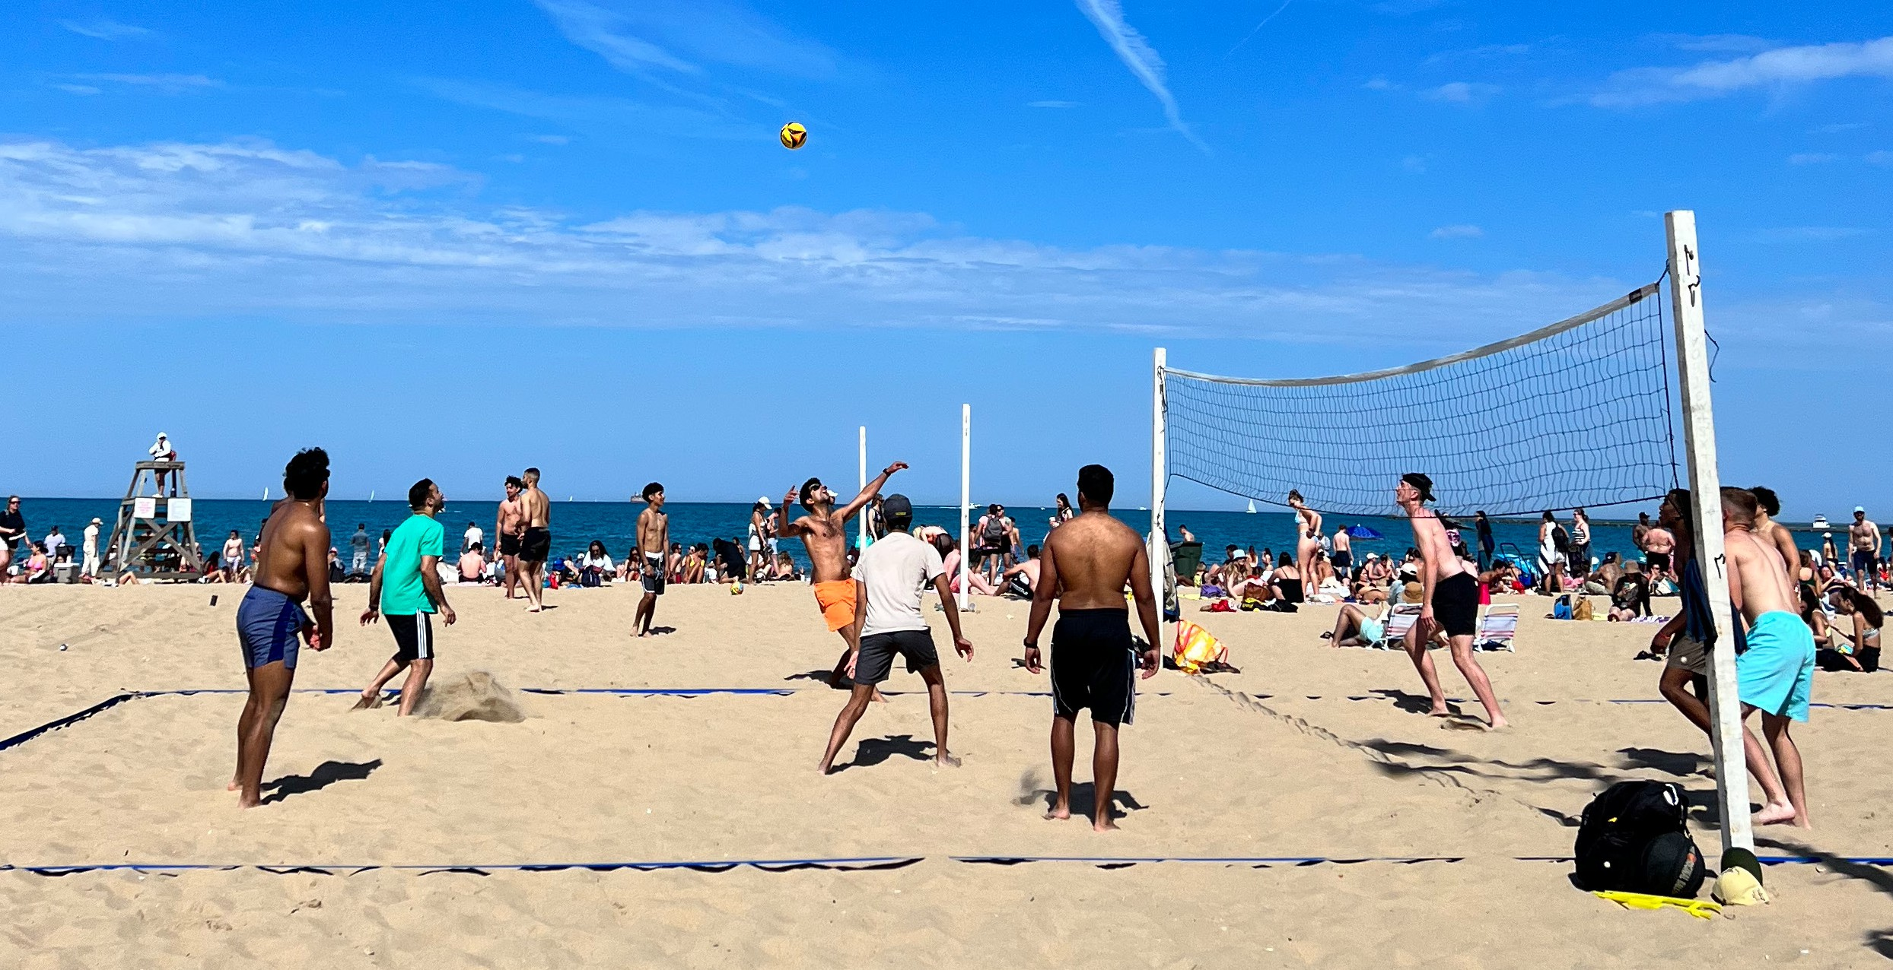


Above, left: The lakefront offers vital habitat for endangered species such as piping plovers. As shoreline
development pressures grow, preserving these natural spaces is essential to supporting biodiversity.

Right: Chicago’s lakefront provides a diverse array of recreational opportunities, encompassing both active and passive pursuits. These
individuals are participating in a beach volleyball match as part of one of
the city’s organized sports leagues.

The Public Trust Doctrine
The public trust doctrine is a legal principle that preserves and protects certain natural and cultural resources for public use.⁷ Public trust land is considered owned by the public and is protected and maintained by the government.

With origins in the Roman Empire, the public trust doctrine would make its way into English Common Law and, eventually, the American legal system.⁸ The doctrine is a legal principle that estab- lishes that certain natural and cultural resources are preserved for public use. Whether referred to as public benefit, interest, use,
or purpose, the spirit of the doctrine is the same.

The purpose and scope of the Illinois doctrine have changed dramat- ically since its inception. While Joseph D. Kearney and Thomas W. Merrill discuss the extensive case law, its historical intricacies, and interpretations in Lakefront: Public Trust and Private Rights in Chicago, three major court decisions shaped the public trust doctrine and made it a robust, if imperfect, mechanism for lakefront protection today.

Illinois Central R. Co. v. Illinois: The Public Trust Reverberates in American Law
In 1892, Illinois Central R. Co. v. Illinois went before the U.S. Supreme Court to determine who owned the land beneath Lake Michigan. The court, suspicious of private interest usurping power from the state legislature, ruled that the state owned the submerged lands “in Trust, which requires the state government to preserve such waters for
the use of the public.”⁹ The court further confirmed that this trust could not be removed, declaring that “the control of the state for the purpose of the trust can never be lost, except as to such parcels as are used in promoting the interest of the public therein or can be
disposed of without any substantial impairment of the public interest in the lands and waters remaining.”

With this ruling, the public trust doctrine became the rule of law in the United States and over the lakefront. The Supreme Court estab- lished that any land below the waters of Lake Michigan is always for the public benefit. Therefore, it needed to be held by the state, in this case, Illinois, in trust to keep it from private sale, development, and/ or benefit.

People ex rel. Scott v. Chicago Park District: “Tax Dollars and Jobs are Not a Public Benefit”
While the public trust doctrine went through a period of obscurity
in the early 20th century, the environmental movement of the 1960s and 1970s revitalized it in the public consciousness.

Legal decisions during this time further underscored the importance of the “public benefit” standard. Courts ruled that commercial growth was not a sufficient reason to cede lakefront land. An example of this is in the 1970s case, People ex rel. Scott v. Chicago
Park District, which stemmed from a 1963 Illinois Legislative act that granted 194 acres of land submerged under Lake Michigan to the U.S. Steel Corporation on Chicago’s southeast side. The state argued that the tax dollars and jobs created by filling in the lake and expanding the U.S. Steel site would be a public benefit.

Perhaps swayed by the public’s growing interest in conserving natural resources, the Illinois Supreme Court upheld that Illinois courts are not bound by “inflexible standards” when considering the public benefit, but have some discretion to assess their magnitude.

The Supreme Court established that any land below the waters of Lake Michigan is always for the public benefit.

With the Scott decision, the court reaffirmed the importance of public benefit by clarifying that
jobs and tax revenue do not meet the threshold of its definition of public benefit.

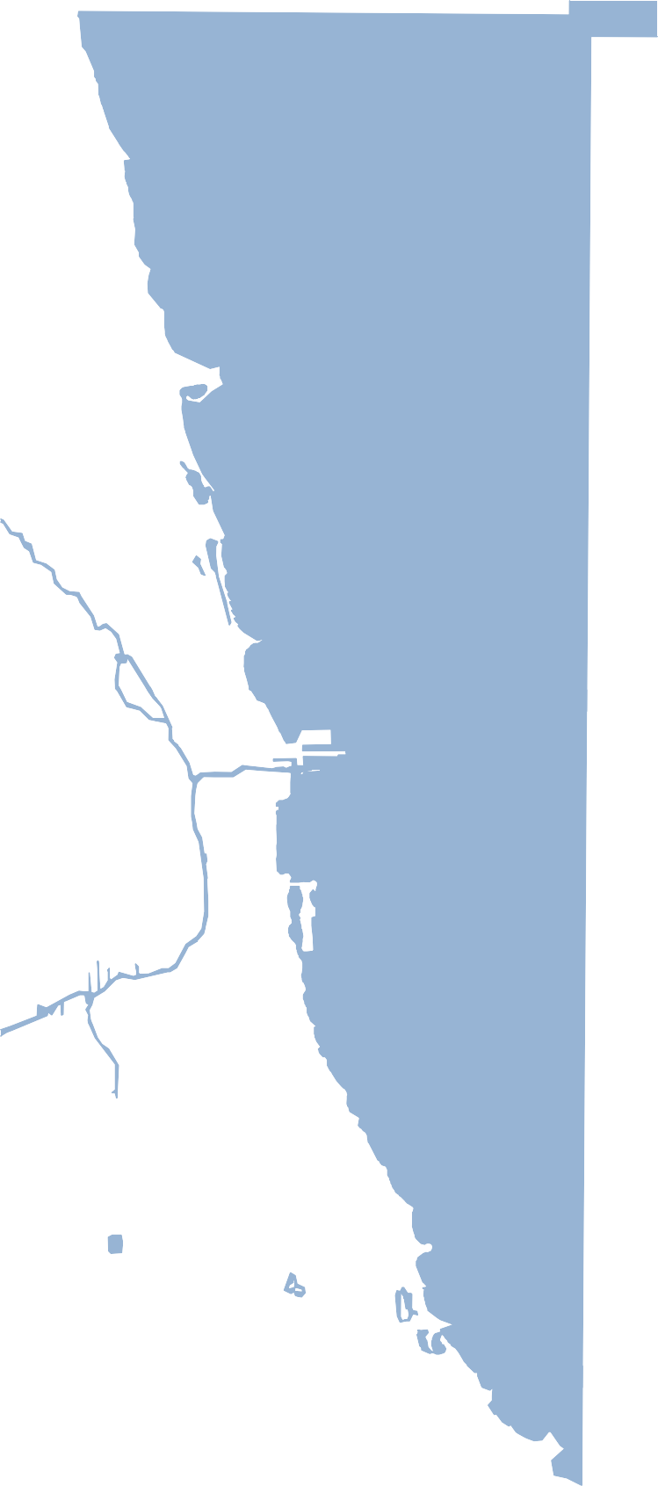
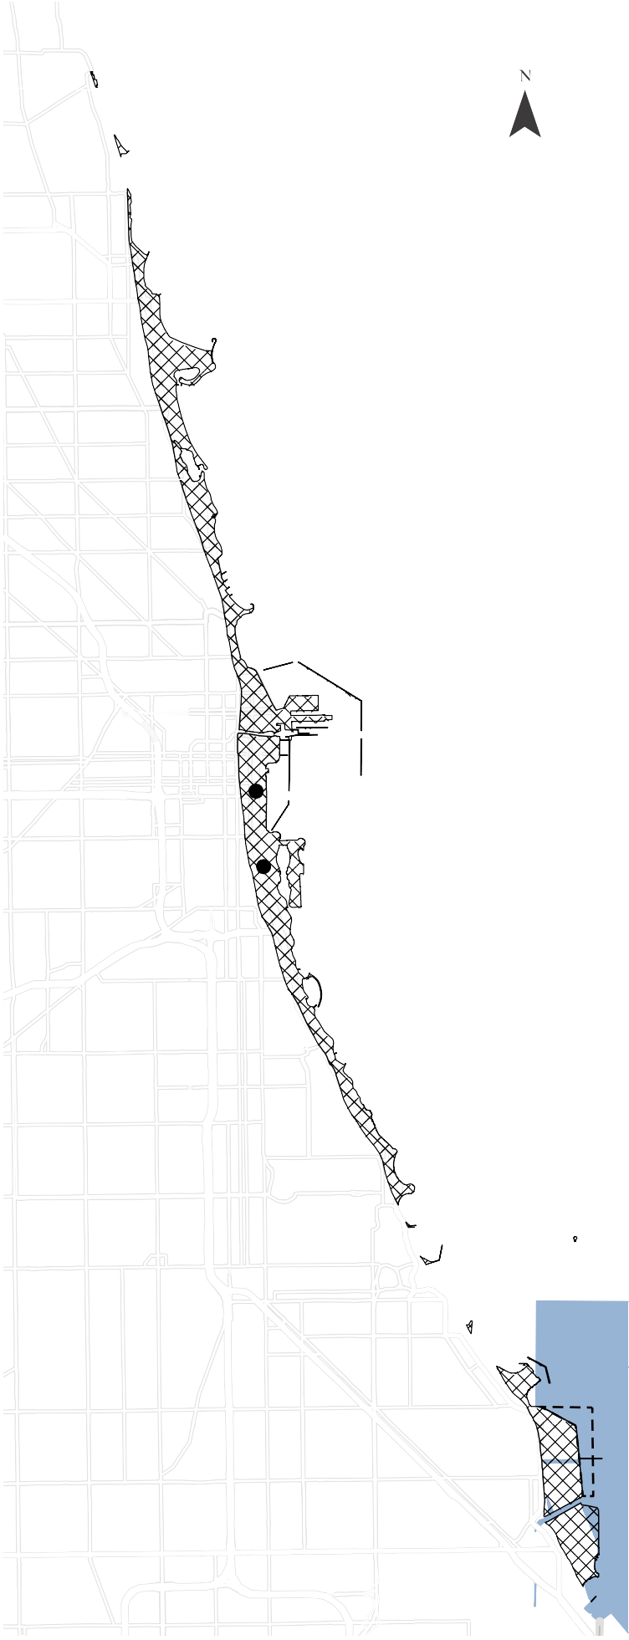
HOWARD
BELMONT
MADISON
ILLINOIS CENTRAL RAILROAD
SOLDIER FIELD
PERSHING
63RD
U.S. STEEL
103RD

The public trust doctrine—
a legal principle that preserves and protects certain natural and cultural resources for public use— has played a significant
role at various sites along the Chicago lakefront. Areas of land
governed by this doctrine, which make up a substantial portion
of the city’s shoreline, are shown on this map.

In blocking the land transfer to U.S. Steel, the court found that “the claimed benefit here to the public through additional employment and economic improvement is too indirect, intangible, and elusive to satisfy the requirement of a public purpose.” They invalidated the bill and prohibited U.S. Steel from aquiring the lakebed to infill and create more land for their operations.

In this case, the court reaffirmed the importance of public benefit by clarifying that jobs and tax revenue do not meet the threshold of its definition of public benefit.

Friends of the Parks v. Chicago Park District: Testing the Bounds of “Public Purpose”
The public trust doctrine was before the Illinois Supreme Court again in 2003 in Friends of the Parks v. Chicago Park District,¹²—also known as the Soldier Field case. In this case, the state authorized the
use of public funds to renovate Soldier Field, located on Chicago Park District-owned land governed by the public trust doctrine and LPO.

In this case, the Illinois Supreme Court reviewed state legislation that approved the renovation to decide if it was constitutional and in compliance with the public trust doctrine. Unlike the Scott case, the court did not find the state’s actions contrary to the public trust doc- trine because the Park District remained the property owner, and the proposed improvements would provide the public with better access to the lakefront, generally through parking and other amenities.

The court pointed out that Soldier Field had served various public purposes since it opened in 1924.“These results do not violate the public trust doctrine even though the Bears will also benefit from the completed project.”13

While the renovation was granted, the Soldier Field case reaffirmed that the public trust doctrine protects the public interest, and this protection can never be removed; and that the courts can review legislative acts to ensure the protection of the public interest. On the other hand, it may also have introduced the legality of private entities benefiting from public land through long-term leases or agreements, so long as a public agency still owns the land.

The Soldier Field decision reaffirmed that the public trust doctrine
protects the public interest, and this protection can never be removed;
and that the courts can review legislative acts to ensure the protection of the public interest.

A Complicated Legal Doctrine Uniquely Impervious to Change
Through this lineage of landmark court rulings, the public trust doctrine’s purpose has changed dramatically since 1892. While lakefront advocates often wield the precedent to dissuade intrusive development, serious legal questions remain regarding its application and governance, making it unreliable for the consistent protection
of the lakefront.

While residents can and should use the public trust doctrine to defend against
intrusive development, the lakefront needs consistent, transparent protection through strong governance.
While the law established the lakebed of Lake Michigan to be public trust land, subsequent court decisions could interpret the scope further, to include public land not connected to Lake Michigan.
Although the court reaffirmed public benefit in multiple decisions, it could have redefined it by accepting long-term leases to private entities in the Soldier Field case. Throughout the last century,
the courts have given varying degrees of deference to the Illinois Legislature’s governing decisions.14

As Thomas and Merrill write in Lakefront, “The Lucas Museum and Obama Presidential Center cases confirm—if further confirmation is needed—that the public trust doctrine serves as a kind of wild card in determining how the development of the Chicago lakefront can proceed. It is unpredictable whether advocacy groups will sue to
enforce the doctrine. It is unpredictable how the courts will respond.”

While residents can and should use the public trust doctrine to defend against intrusive development, the lakefront needs consistent, transparent protection through strong governance. This was the aspiration and intent that motivated the passage of the LPO in 1973.

What is “Intrusive Development?”
This report defines intrusive development as a project that intrudes or impairs, by use, scale, intensity, or design, the intended legal protections set forth in the public trust doctrine and LPO outlined in this report. For instance, a proposed lakefront structure that rises to towering heights; causes significant wildlife deaths or environmental degradation; impedes the public’s access due to its size, activities, or private benefit; or includes aesthetic features incompatible with the surrounding natural landscape could cross a legal threshold of “intrusive.”

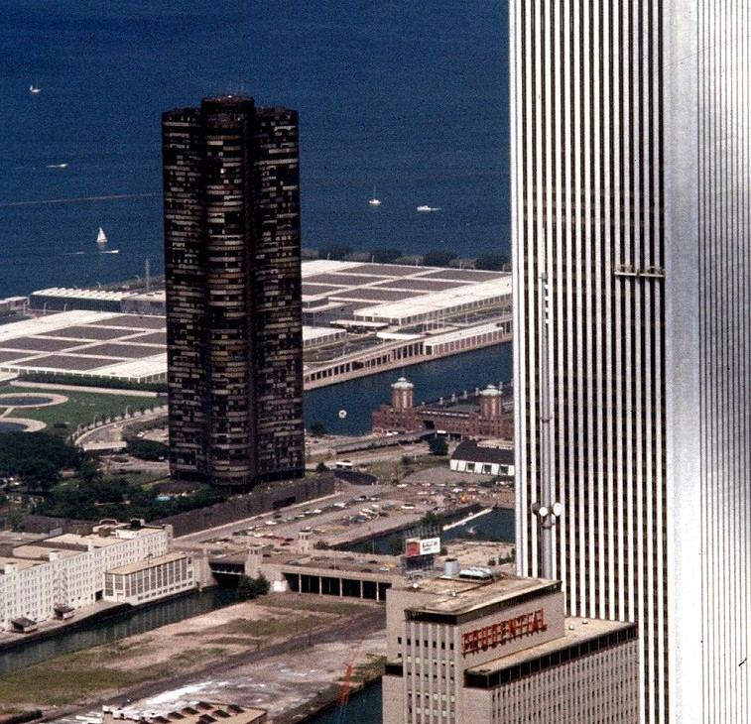
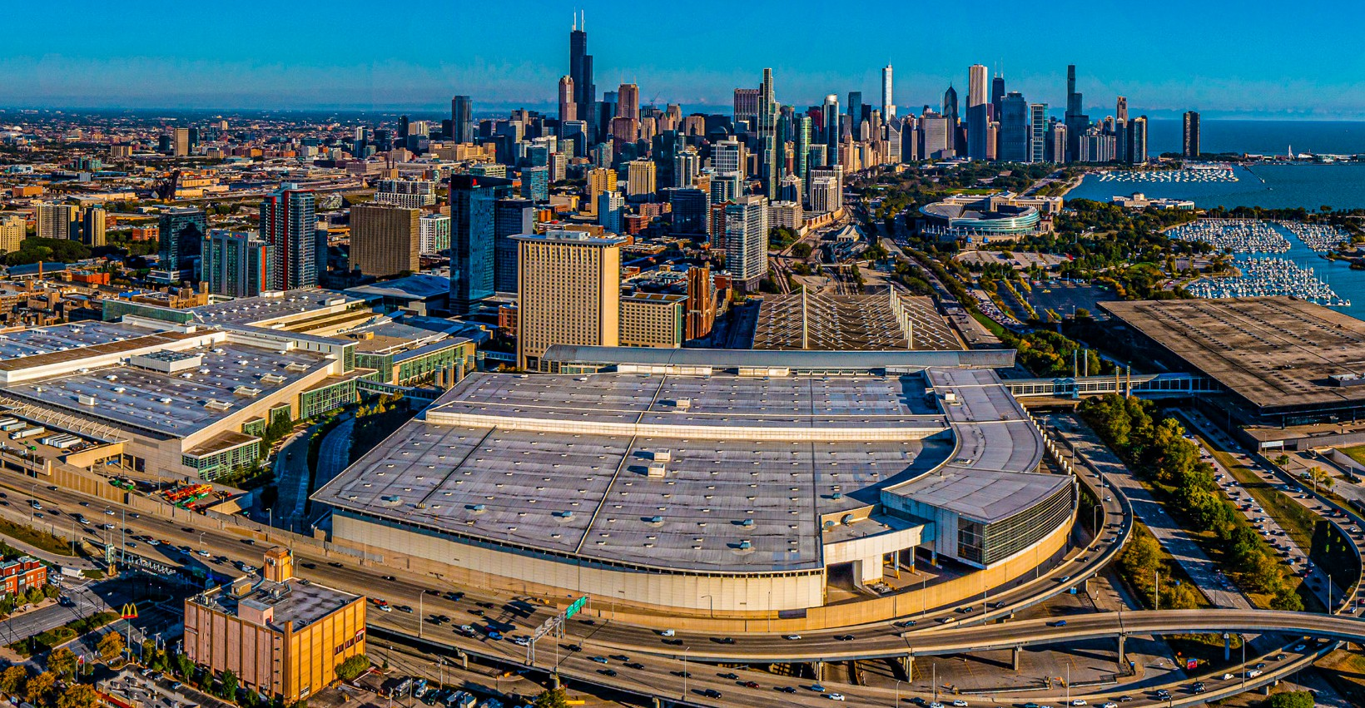
The Lake Michigan and Chicago Lakefront Protection Ordinance
In the 1960s, massive developments on the lakefront sparked public protests.¹⁵ McCormick Place opened in 1960 with 320,000 square feet of exhibition space. In 1965, Lake Shore Drive expanded through Jackson Park, and construction began on Lake Point Tower down- town. When a fire destroyed McCormick Place in 1967, it was rebuilt and expanded to 2.6 million square feet.
Fearing more intrusive development on the lakefront, citizen advocates, civic leaders, and a coalition of nonprofits, including Openlands, pushed the city to publish the 1972 Lakefront Plan of Chicago and pass the LPO in 1973. The purpose of the ordinance was—and remains today—to create a district with “special environmental, recreational, cultural, historical, community and aesthetic interests and values” along the Lake Michigan shoreline and “insure the preservation and protection of that district and of every aspect of its interest and value.”16

The LPO functions as an “overlay” on top of the city’s underlying zoning classifications across three zones: the offshore zone
(i.e., waters of Lake Michigan), public use zone (i.e., beaches and public park space), and private use zone (i.e., lakefront-adjacent commercial and residential areas).17
Above, left: McCormick Place opened in 1960 with 320,000 square feet of exhibit space and has since expanded to over 2.6 million square feet across four buildings, including the Lakeside Center on the eastern side of DuSable Lake Shore Drive. This building, in particular, reflects the ongoing tension between the built and natural environments along the lakefront. Once a major site
of bird collisions, it has recently begun implementing bird-friendly measures.

Right: Completed in 1968 with some controversy, Lake Point Tower remains the only skyscraper located east of DuSable Lake Shore Drive. In the background is the Jardine Water
Purification Plant, another prominent facility on the lakefront. In the decades since these developments, Chicago
has made efforts to better integrate its two major downtown waterfronts— the Chicago River and the lakefront.

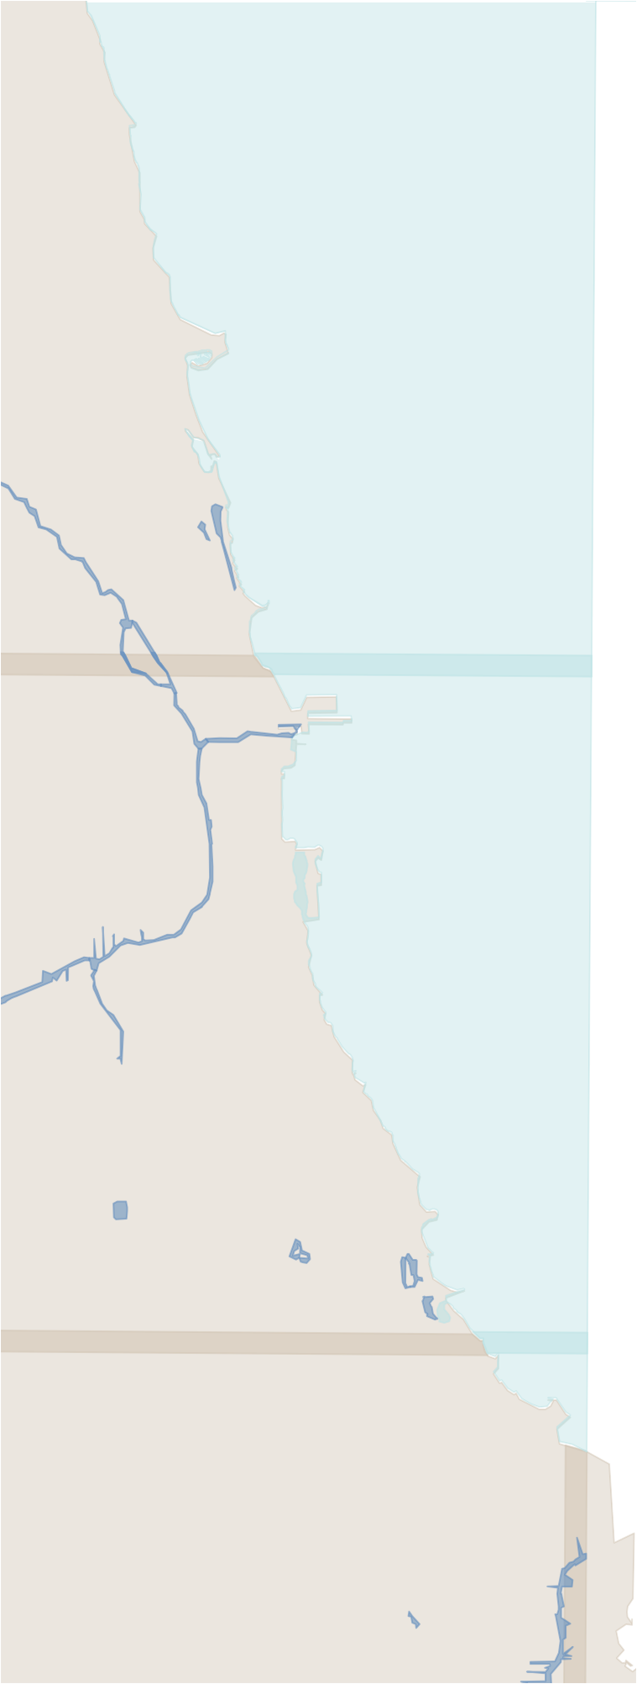




HOWARD
city li mit
Lake Michigan & Chicago Lakefront Protection Ordinance—
District Zones
BELMONT
MADISON
PERSHING
63RD
103RD
Public Use Zone Private Use Zone
Offshore Zone

The LPO functions as an “overlay” on top of the city’s underlying zoning classifications across three zones: the offshore zone (i.e., waters of Lake Michigan), public use zone (i.e., beaches and public park space), and private use
zone (i.e., lakefront-adjacent commercial and residential areas).

12

Development Approval Process vs. the Intent and Spirit of the LPO
Under the 13 “stated purposes” of the LPO, any physical change (i.e., development) within the Lakefront Protection District is unlawful without approval from the Chicago Plan Commission.¹⁸ This special review also applies when a public agency sells, leases, buys, or disposes of real property within the Lakefront Protection
District to a private entity (e.g., Chicago Park District lease of Soldier Field). In addition to the purposes, the review requires adherence
to the 14 “basic policies” of The Lakefront Plan of Chicago.¹⁹ The 13 purposes and 14 policies are provided on page 14 of this report.

The interpretation of the 13 purposes of the ordinance and
the 14 policies of the plan is primarily determined through the LPO application and review process of the Chicago Department of Planning and Development (DPD), the Chicago Buildings Commissioner, and the Plan Commission.²⁰ The LPO and the
Lakefront Plan are silent on any thresholds for compliance with the 13 purposes and 14 policies, resulting in a largely subjective review process. For example, an applicant may respond generally to
how their project meets the policies and purposes, and it is left to the Plan Commission to decide if that is sufficient. Notably, several major projects that cleared the Plan Commission never came to fruition due to public dissent and the legal challenges referenced earlier.

Upon receiving a completed application, DPD will forward it to the Plan Commission for consideration. The Plan Commission must give public notice and hold public hearings on the application. Public notice must be given between 15 to 30 days prior to the hearing, and the DPD recommendations relating to the application must be made available to the Plan Commission and the public at least five days prior to the hearing.²¹ At these hearings, the public is afforded a reasonable opportunity to express its opinion.

In practice, however, public notice of the hearing often occurs in relative obscurity since the LPO only requires notices to be published in a newspaper of general circulation in Chicago and mailed to property owners within 250 to 400 feet of the project site. In cases where the public sees the notice, two weeks does not afford adequate discussion. As a result, the review process can inhibit public involvement and accountability.

Public notice of the hearing often occurs in relative obscurity since the LPO only requires notices to be published in a newspaper of general circulation in Chicago and mailed to property owners within 250 to 400 feet
of the project site.

Read The Lakefront Plan of Chicago at :
openlands.org/lakefrontplan

LAKE MICHIGAN & CHICAGO LAKEFRONT PROTECTION DISTRICT
The Lake Michigan and Chicago Lakefront Protection District regulates development along Chicago’s lake- front. Any physical change to property within the district requires review and approval. The repair or rehabilita- tion exceeding 50% of the total replacement cost of an existing structure also triggers review and approval, as does any proposal to increase the site coverage or height of an existing building, or to alter any structure containing more than three dwelling units.

Purpose and Goals
The Lakefront Protection District Ordinance has 13 specific purposes (Sec.16-4-030).

- To promote and protect the health, safety, comfort, convenience, and the general welfare of the people and to conserve the City’s natural resources.

- To identify and divide the district into zones where- in development is restricted and regulated.

- To maintain and improve the purity and quality of the waters of Lake Michigan.

- To insure that construction in the lake or modifica- tion of the shoreline will not cause environmental damage or diminish water quality; and to insure fish, birds and other fauna are recognized and supported.

- To insure that the lakefront is devoted only to pub- lic purposes and to expand the quantity and quality of lakefront parks.

- To promote and provide for continuous pedestrian movement along the shoreline.

- To promote and provide for pedestrian access to the lakefront at intervals of one-fourth mile and ad- ditional places where possible, and to protect and en- hance vistas at these locations and where possible.

- To promote and provide for improved public trans- portation access to the lakefront.

- To insure that no roadway of expressway stan- dards shall be permitted.

- To insure that development of properties adjacent to the lakefront implement the purposes above.

- To achieve the above-stated purposes through the public acquisition of property.

- To define and limit the powers and duties of the administrative body and officers as provided herein.

- Nothing contained in the ordinance shall be deemed to be a waiver or consent for any activity that may be otherwise required by law.

Evaluation Criteria
The Lake Michigan and Chicago Lakefront Protection Ordinance outlines 14 polices by which development along the lakefront is evaluated.

- Complete the publicly owned and locally controlled park system along the entire lakefront.

- Maintain and enhance the landscaped, spacious and continuous character of the lakeshore parks.

- Continue to improve the water quality and ecologi- cal balance of Lake Michigan.

- Preserve the cultural, historical, and recreational heritage of the lakeshore parks.

- Maintain and improve the formal character and open water vista of Grant Park with no new above- ground structures permitted.

- Increase the diversity of recreational opportunities while emphasizing lake-oriented leisure activities.

- Protect and develop natural lakeshore park and water areas for wildlife habitation.

- Increase personal safety.

- Design all lake edge and lake construction to pre- vent detrimental shoreline erosion.

- Ensure a harmonious relationship between lake- shore parks and community edges but in no instance allow private development east of Lake Shore Drive.

- Improve access to lakeshore parks and reduce vehicular traffic on secondary park roads.

- Strengthen the parkway characteristics of Lake Shore Drive.

- Ensure all port, water supply, and public facilities are designed to enhance lakefront character.

- Coordinate all public and private development within the water, park, and community zones.

The Lakefront Plan of Chicago, published in 1972, outlined 14 “Basic Policies for the Lakefront of Chicago” and The Lakefront Protection Ordinance of 1973 laid out 13 “Purposes”. These have been incorporated into the current Development Manual for Chicago Plan Commission Projects—an informational guide offered as an application resource for developers on the City of Chicago’s website. The 14 Basic Policies have been renamed “Evaluation Criteria” and the 13 Purposes have been adapted as “Purposes and Goals”.

Department of Planning and Development: Access and Safety Required; Environmental Protection Optional
The Plan Commission receives staff services from DPD. The LPO lists specific duties and responsibilities for the DPD Commissioner, which include coordinating with other public agencies, conducting investigations, and preparing written recommendations. DPD is also required to forward Planned Development applications and other permits in the LPO district to the Plan Commission.²²

Notably, one of the few differences between the original 1973 Lakefront Protection Ordinance and today’s version is the removal of the requirement to assess environmental impact. Once the respon- sibility of the Commissioner of Environmental Control, today the LPO authorizes but does not mandate DPD to investigate a project’s ecological and environmental impact. Whether or not a DPD inves- tigation occurs, the findings must be sent to the Plan Commission and constitute a part of the record upon which it makes its decision. While the city’s transportation, police, and fire departments, along with the Mayor’s Office for People with Disabilities, must review and approve the application to ensure fair public access and safety, no such review is required to ensure environmental protection.

The review process does require applicants to respond to the
13 purposes outlined in the LPO and 14 policies outlined in the 1972 Lakefront Plan of Chicago. Yet, responses can be subjectively written by the applicant and interpreted by the Plan Commission. As a result, an applicant may move through the approval process without under- going a genuine environmental analysis.

Notably, one of the few differences between the original
1973 Lakefront Protection Ordinance and today’s version is the removal of the requirement to assess environmental impact.

16-4-130 Investigation.
The commissioner of planning and development may, upon receipt of any proposal or application as hereinabove provided, conduct an investigation of the ecological and environmental impact of said proposal. The findings of the Commissioner
of Planning and Development shall be forwarded to the plan commission and shall constitute a part of the record upon which the plan commission shall premise its
decision regarding the proposal or application.

Reprinted from the present-day Lake Michigan and Chicago Lakefront Protection Ordinance.

Chicago Zoning as Precedent for Protection
Chicago Zoning laws are significant for setting a precedent to protect open and natural areas on the lakefront. The requirements of the LPO will supersede zoning requirements in the event of a discrepancy between the two. However, it is important to understand the ramifications of zoning laws, particularly, when Planned Developments²³ (PD) fall within the LPO.

In 1923, Chicago enacted zoning laws to regulate the development, use, and occupancy of land. The Bureau of Zoning oversees Chicago zoning within the City’s Department of Planning and Development. Most of the lakefront has a base zoning district of Parks and Open Space (POS).²⁴ The purpose of a POS district is to preserve, protect, and enhance lands set aside for public open space, parks, and beaches. Zoning lakefront land for public and open space is a forceful declaration by the
government that the lakefront should be open, accessible, and public.

Another base zoning district commonly found along the lakefront is Planned Development. This is a zoning des- ignation in Chicago that allows for more flexible develop- ment. A PD requires more public review and coordination with city planners for large development projects. PDs are set, amongst other reasons, to encourage protecting and conserving natural resources. For example, any project within 100 feet of the Chicago River automatically triggers a PD designation regardless of the base zoning. Through the PD process, these projects must comply with design standards that include protections like ungated river access for the public and marked trails.

Projects in PDs are also required to comply with the city’s Sustainable Development Policy, which offers a menu of options that reflect best practices in sustainable construction and green infrastructure solutions to help
Chicago achieve wide-ranging climate and resiliency goals. PDs within the Lakefront Protection District must adhere to the LPO.

It’s important to note that Chicago zoning is complex and constantly changing. Restrictions applicable to
classifications and individual properties frequently change because of site-specific approvals from the Zoning Board of Appeals and site-specific waivers from the Bureau of Zoning. While these changes allow public hearings, they also make zoning restrictions an unreliable shield against intrusive developments along the lake. In addition, the mayor appoints the DPD Commissioner, Chicago Plan Commission members, and Zoning Board of Appeals members, making zoning subject to political influence. Still, zoning is a valuable opportunity for the public to attend hearings and participate in civic discourse.

Aldermanic Prerogative
Aldermanic prerogative heavily influences ward-level zoning decisions in Chicago, including the LPO. Currently, 13 wards share some of the LPO district’s private or public use zones. For better or worse, alderpersons are still given deference in zoning and permitting within those zones. An applicant within an LPO zone must provide
“evidence of aldermanic contact” when applying for a development permit.26

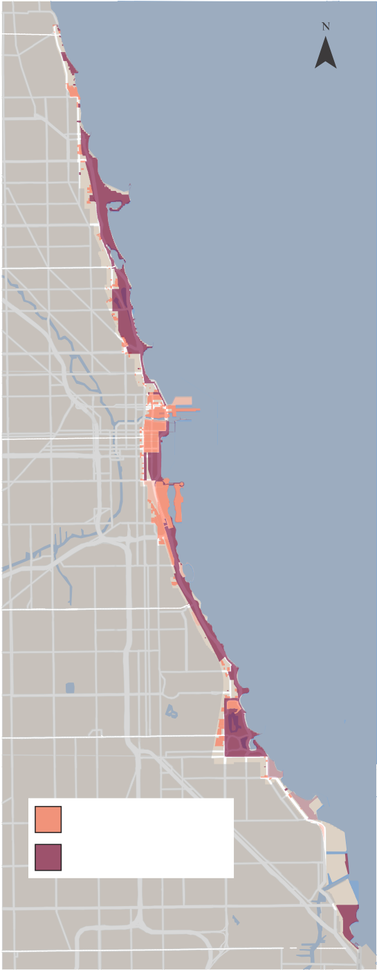
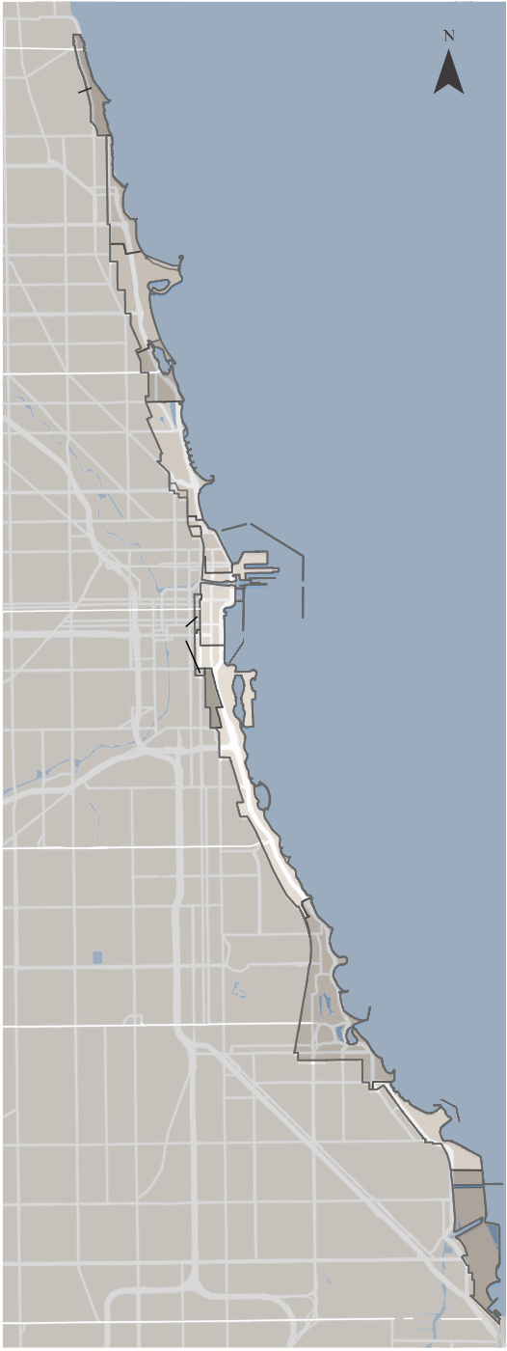
Left: Chicago Zoning laws are significant for setting a precedent to protect open and natural areas on the lakefront.
HOWARD
Select City of Chicago Zoning Within the LPO
BELMONT
MADISON
PERSHING
63RD
Planned Development
Parks and Open Space
103RD
HOWARD

49
48
Lakefront Portions of
Chicago Wards
46
BELMONT
44

43
2
MADISON
42
34
3
4
PERSHING
63RD
5
7
10
103RD

Right: Chicago’s lakefront intersects with 13 of the city’s 50 wards.

A Defense Against Development, In Need of Strengthening
Since its adoption in 1973, the LPO has prevented the development of the lakefront and created mechanisms for public discourse and review by the Plan Commission, zoning committee, and City Council. Nevertheless, the gaps in long-term planning, public transparency, and environmental review create ways for too many politically favored and/or economically lucrative development proposals to pass through the review process. This subjective review leads to public backlash and costly and unnecessary lawsuits. Over time, it diminishes the lakefront’s intrinsic value, the opposite of the ordinance’s intent.

North
HOWARD
Central
South


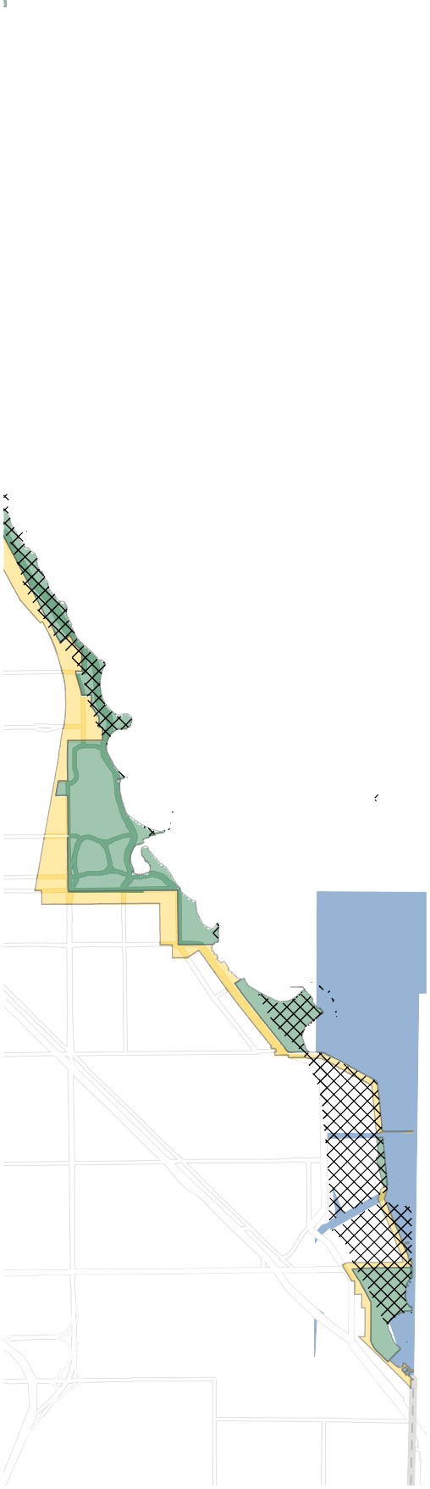
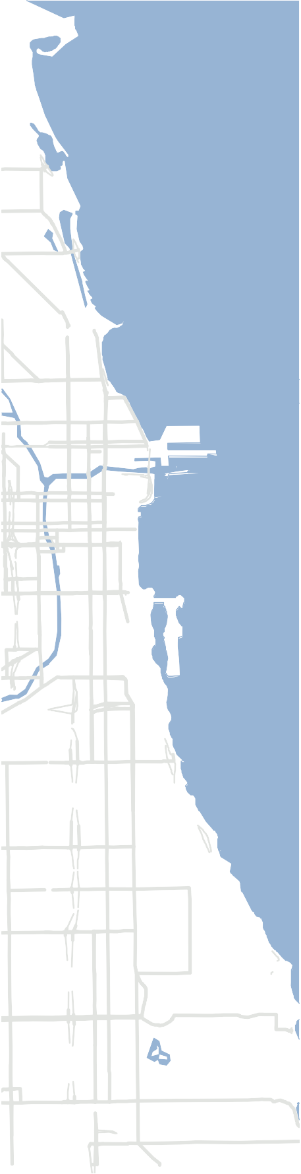

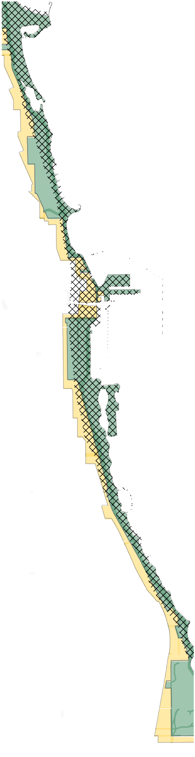
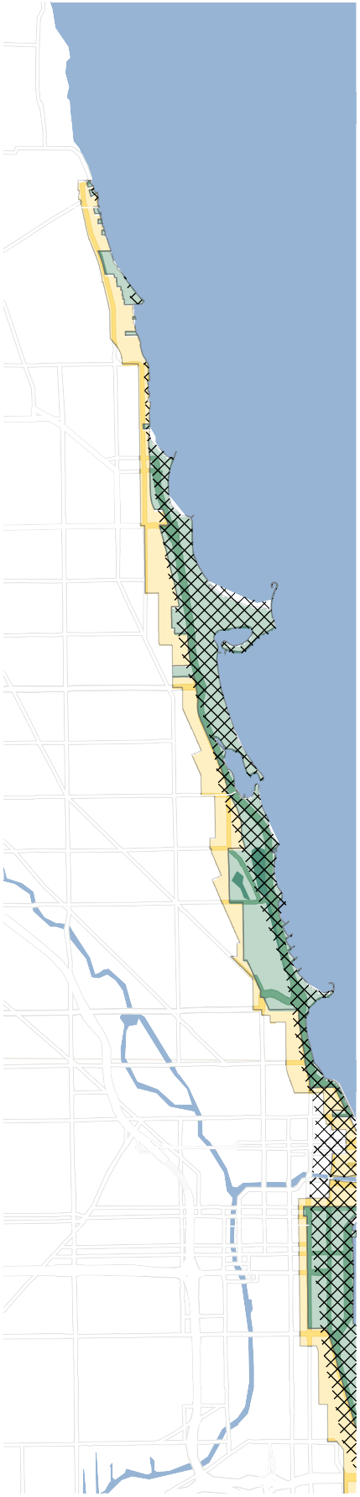


Public Trust Doctrine LPO Private Use Zone LPO Public Use Zone
LPO Off Shore Zone

MADISON

BELMONT

63RD

PERSHING

MADISON

103RD

A north to south rendering of LPO public and private use zones including areas of Lake Michigan infill associated with the public trust doctrine.
63RD

Recommendation: Strengthening the LPO is the Best Defense for an Open, Clear, and Free Lakefront
Despite Chicago’s fervent affection for its lakefront and over a century of improve- ments and protections, the values of an open, natural, and public lakefront are still at risk.

The LPO is a municipal ordinance created to protect the public’s lakefront from intrusive development. It is, therefore, the best vehicle for reform to achieve stronger protection now and in the future.

Openlands recommends strengthening the LPO and its governance with the following strategic amendments that ensure visionary planning to guide governing decisions, mandate environmental protections, and encourage healthier public debate:

Require periodic updates to the Lakefront Plan of Chicago and Lakefront Protection District to revitalize the city’s accountability to its core concepts and vision.

The lakefront has undergone significant changes since The Lakefront Plan
of Chicago was created in 1972, providing the framework for the passage of the LPO. While the Chicago Park District has developed numerous master plans and frameworks for individual parks—and even for the entire north side
of the lakefront—it has never updated the Lakefront Plan itself. Similarly, the boundaries of the Lakefront Protection District have minimally changed.

It is unclear whether the Plan Commission, DPD, or Chicago Park District regularly use or reference the Lakefront Plan. The plan is not available on the city’s website, nor is it easily accessible online or in print, limiting public awareness of its contents.

While much of the Lakefront Plan and District remains relevant and foundational, an update to both would better reflect today’s challenges and opportunities. This would help guide public discussions, inform decisions by the Plan Commission and the city’s approval processes, and shape the
Chicago Park District’s future capital investments, creating a more connected, equitable, and enjoyable lakefront for all.

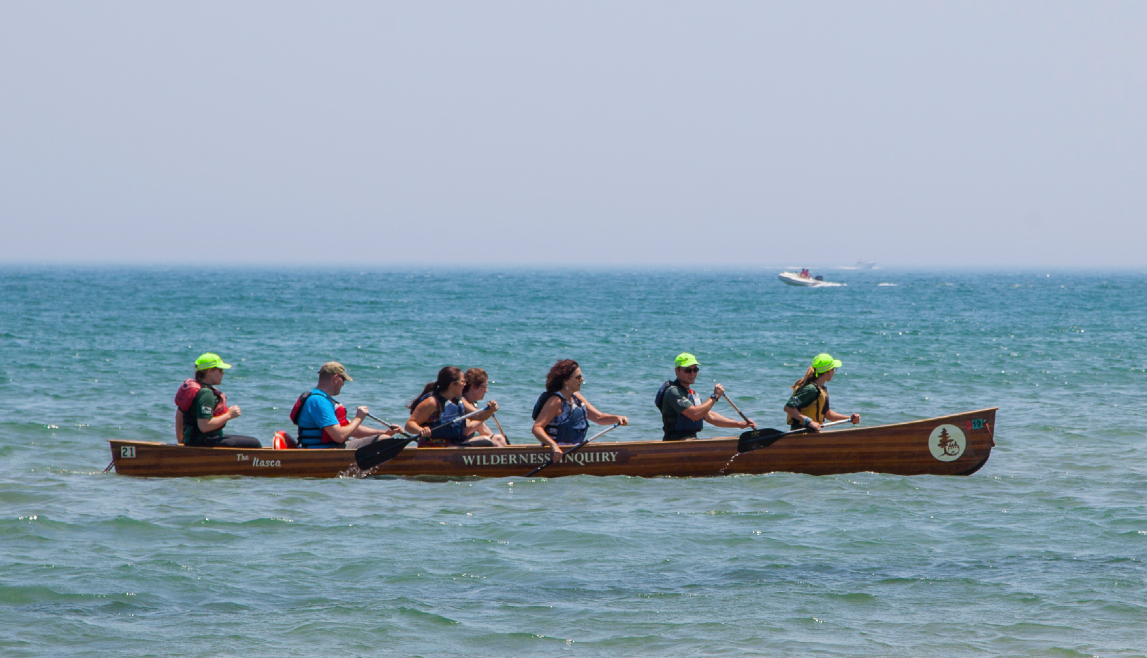
The Chicago lakefront is part of the four- state Lake Michigan Water Trail system, offering paddlers a unique opportunity to experience the city’s iconic skyline and diverse wildlife from the water.
add citation for Chicago River Code
I don’t know what that means

Create environmental design and use standards for proposed developments and improvements for a more objective review process.

Create environmental design and use standards to establish a more objective review process.

While the private and public use zones in the Lakefront Protection District are clearly defined in the LPO, it is unclear what specific standards, if any, developments must meet within this special district.

To promote a unified aesthetic and enhance the natural environment, DPD should adopt specific design guidelines for developments in the private zone, similar to the guidelines for the Chicago River. Buildings in the public and offshore zones should adhere to the highest design standards to protect natural resources and ensure public enjoyment of the lakefront.

For example, adopting standards like bird-friendly window designs can significantly reduce bird collisions during migration. The installation of bird- safe film at McCormick Place Lakeside Center has already resulted in
a dramatic reduction in bird fatalities, with over a 90% decrease in crash deaths during the 2024 fall migration season.²⁷


By implementing such design guidelines, the city can better protect wildlife, preserve natural habitats, and enhance public access to the lake, ensuring that all Chicagoans can fully enjoy this vital resource.

Mandate environmental impact studies.

Currently, DPD is not required to conduct environmental studies for develop- ment approval within the Lakefront Protection District, despite the fact that the original 1973 legislation mandated them. This is inadequate, considering that the LPO explicitly prioritizes environmental resource conservation in
its 13 stated purposes and 14 plan policies.

The city should amend the LPO to once again require environmental impact studies. This would provide decision-makers and the public with crucial information on how developments might affect wildlife, air and water quality, light pollution, public access, and other related factors.

Upholding the principles of the LPO and the Lakefront Plan through scientif- ically backed environmental impact studies is essential to safeguarding our most valuable civic asset and largest environmental resource.
With over 50 miles
of trails and footpaths, the lakefront connects communities to nature, recreation, and one another— supporting health
and well-being across the city.

Strengthen notice requirements to ensure meaningful public deliberation and debate.

While the current LPO review process is thorough, it is somewhat subjective, and the public participation process is relatively passive. Currently, the ordinance only requires 15 days’ public notice before a hearing, and the public review period for application materials is limited to just five days before a Plan Commission meeting. This is insufficient time for the public to fully consider and debate proposals, which may contribute to the lawsuits that follow the current review process.

To encourage more robust civic engagement, the LPO should be updated to provide earlier and more accessible notice, in line with modern information- sharing practices. Additionally, clarifying which application materials must be made public and extending the public review period would promote more informed discussions about proposed developments.

Strengthening the public review process is essential for effective governance of the lakefront and will lead to a healthier, more inclusive debate.

Require large developments to meet higher overall standards.

While large developments along the shoreline trigger a Planned Development review, they are not required to meet any additional standards specific to
the Lakefront Protection District. In contrast, large developments along the Chicago River must comply with extra regulations, such as minimum setbacks and continuous riverside trails.

The LPO should establish additional requirements for large developments, setting a higher threshold for design standards, environmental impact studies, and public transparency. Large developments have the potential to signifi- cantly impact how people and wildlife experience the lakefront, so they should be held to the highest standards of review. This ensures that developments not only enhance the public’s enjoyment of the lakefront but also benefit future generations.
To learn more about the lakefront policy agenda and voice your support, visit openlands.org/lakefrontpolicy.

Conclusion
The 1909 Plan of Chicago states: “The improvement of the Lake front from Winnetka to the Indiana Line is an economic necessity.” Plan authors Daniel Burnham and Edward Bennett, as well as many visionaries before and since, wagered that Chicago’s economic strength depends upon a forever open, clear, and free lakefront. It is clear so many decades later that this theory was prophetic. The system of stately public parks that ring Chicago’s lakefront became a civic trademark that drew businesses, visitors, and investments to the urban core precisely because it offered a unique oasis of open space—urbs in horto, to borrow from Chicago’s motto—in the center of a commercial powerhouse.

However, this gateway to economic growth is not guaranteed. This report shows that Chicago’s commitment to preserving its lakefront has been resilient. Still, the legacy of these efforts remains fragile, partly because the laws protecting the shoreline from intrusive development can be subjective and need strengthening. The city’s success
in maintaining the natural character of the lakefront—and sustaining a key driver of its economic prosperity—will depend on reinforcing the laws that safeguard the shoreline.

This work should begin with amending the Lake Michigan and Chicago Lakefront Protection Ordinance. As the city contemplates new proposals that could impact the aesthetics of lakefront land, water, and wildlife, the need to renew and strengthen these protections is particularly timely. In honor of the generations of Chicagoans who fought to preserve this vital civic treasure, this effort is not only critical but also, arguably, long overdue.

Stretching across the seasons and across time, the Chicago lakefront is where countless memories are made—woven into the fabric of life in the city.


The Chicago Lakefront: Protected, Yet Precarious 23

References
  - Zeymo, Alek. “Urban American Indian Undercount in the 2020 Census Went Underreported.” Ncuih.Org. National Council of Urban Indian Health, August 28, 2023. https://ncuih.org/2023/08/28/urban-american-indian-undercount-in-the-2020-census-went-un- derreported/.

  - City of Chicago. “Title 16 Chapter 16-4 Lake Michigan and Chicago Lakefront Protection.” Codelibrary.Amlegal.Com. City of Chicago, January 10, 2025.

  - “Off-street Pedestrian Paths.” Datahub.Cmap.Illinois.Gov. National Council of Urban Indian Health, March 7, 2023. https://datahub.cmap.illinois.gov/datasets/
CMAPGIS::off-street-pedestrian-paths/explore?location=41.825966%2C-88.111393%2C8.62.

  - “Our Lakefront.” Https://Activetrans.Org. Active Transportation Alliance, March 7, 2023. https://activetrans.org/our-work/walking/our-Lakefront.

  - “Protecting and Enjoying Birds.” Chicago.Gov. City of Chicago, Accessed February 18, 2025. www.chicago.gov/city/en/progs/env/protecting_and_enjoyingbirds.html.

  - Kearney, Joseph D., and Thomas W. Merril. 2021. Lakefront: Public Trust and Private Rights in Chicago. Cornell University Press.

  - “Public Trust Doctrine.” Law.Cornell.Edu. Cornell Law School, May 1, 2022. www.law.cornell.edu/wex/public_trust_doctrine.

  - Sax, Joseph. Liberating the Public Trust Doctrine from its Historical Shackles, 14 U.C. Davis L. Rev. 185 (1 980–1 98 1) p. 186

  - Illinois Central R. Co. v. Illinois, 146 US 387, 452 (1892).

  - Illinois Central R. Co. v. Illinois, 146 U.S. 387, 453 (1892).

  - People Ex. Rel. Scott v. Chicago Park Dist., 66 Ill. 2d at 81 (1976).

  - Friends of the Parks v. Chicago Park Dist., 786 N.E. 2d 161 (Ill. 2003).

  - Friends of the Parks v. Chicago Park Dist., 786 N.E.2d at 170 (Ill. 2003).

  - Kearney, Joseph D., and Thomas W. Merril. 2021. Lakefront: Public Trust and Private Rights in Chicago. Cornell University Press.

  - Lois, Willie. 1972. Forever Open, Clear and Free. 1st ed. The University of Chicago Press.

  - City of Chicago. “Title 16, Chapter 16-4-020, Lake Michigan and Chicago Lakefront Protection.” Codelibrary.Amlegal.Com. City of Chicago, January 10, 2025.
https://doi.org/0-0-0-48022.

  - City of Chicago. “Title 16 Chapter 16-4-070 Lake Michigan and Chicago Lakefront Protection.” Codelibrary.Amlegal.Com. City of Chicago, January 10, 2025.
https://doi.org/0-0-0-48022.

  - City of Chicago. “Title 16 Chapter 16-4-030 Lake Michigan and Chicago Lakefront Protection.” Codelibrary.Amlegal.Com. City of Chicago, January 10, 2025. https://doi.org/0-0-0-48022.

  - Chicago Plan Commission, Lakefront Plan of Chicago, 1972, Box: 47, Folder: 21. Chicago City- Wide Collection, spe-nhrc-ccw. Special Collections Unit at Harold Washington Library Center.

  - “Development Manual for Plan Commission Projects.” Chicago.Gov. City of Chicago, Accessed February 12, 2025. https://www.chicago.gov/city/en/depts/dcd/supp_info/development_manualfor- plancommissionprojects.html.

  - City of Chicago. “Title 16 Chapter 16-4-100 Lake Michigan and Chicago Lakefront Protection.” Codelibrary.Amlegal.Com. City of Chicago, January 10, 2025.

  - City of Chicago. “Title 16 Chapter 16-4-110 Lake Michigan and Chicago Lakefront Protection.” Codelibrary.Amlegal.Com. City of Chicago, January 10, 2025.

  - “Chapter 17-8 Planned Developments.” Codelibrary.Amlegal.Com. City of Chicago, July 1, 2024.

  - “17-6-0200 POS, Parks and Open Space District.” Codelibrary.Amlegal.Com. City of Chicago, July 1, 2024.

  - “Sustainable Development Policy.” Chicago.Gov. City of Chicago, July 1, 2024. https://www.chicago.gov/city/en/sites/sustainable-development-policy/home.html.

  - “Development Manual for Plan Commission Projects.” Chicago.Gov. City of Chicago, Accessed February 12, 2025. https://www.chicago.gov/city/en/depts/dcd/supp_info/development_manualfor- plancommissionprojects.html.

  - “Bird Deaths Plummet at Chicago’s McCormick Place Lakeside Center after Safety Film Installed.” Phys.Org. City of Chicago, January 10, 2025. https://phys.org/news/2025-01-bird- deaths-plummet-chicago-mccormick.html.

Photo credits
Cover: Allix Rogers; page 6, beach volleyball: Huan Song.

Openlands gratefully acknowledges the McDougal Family Foundation for their generous support of this report and our work to safeguard Chicago’s lakefront.












Openlands protects the natural and open spaces of northeastern Illinois and the surrounding region to ensure cleaner air and water, protect natural habitats and wildlife, and help balance and enrich our lives.
Since our founding in 1963 as a program of the Welfare Council of Metropolitan Chicago, Openlands has been at the forefront of the urban conservation movement. Today, Openlands works across areas to advance nature-based solutions to climate change, improve the health and well-being of communities, and create a more verdant region for all. For more information, please visit openlands.org.

